

NOTICE OF COMPLETE APPLICATION AND PUBLIC MEETING
TO INFORM THE PUBLIC OF A ZONING BY-LAW AMENDMENT

TAKE NOTICE that the Council for The Corporation of the Municipality of Powassan has received a complete application under Section 34 of the Planning Act, R.S.O. 1990, c.P. 13 as amended, to inform the public of a proposed Zoning By-law Amendment.

The public meeting is being held for the application described below to enable interested members of the public to understand and comment on a proposed Zoning By-law Amendment.

DATE AND LOCATION OF PUBLIC MEETING

Date: Tuesday, January 18, 2022
Time: 6:30 pm
Location: Municipality of Powassan – 250 Clark Street

DETAILS OF THE ZONING BY-LAW AMENDMENT

The purpose and effect of the proposed Zoning By-Law Amendment is to amend the Restricted Area (Zoning) By-Law No. 2003-38, as amended, for the lands described as Lot 6, Plan 44, (Civic Address: 528 and 526 Main Street, Powassan), in the Municipality of Powassan.

The application, if approved, would rezone the subject property from CV1 (Village Commercial) to CV1-6 (Village Commercial - Exception Six). The proposed exception will recognize the existing residential unit located on the ground floor at the front of the building. A new second residential unit is also proposed on the ground floor and the second storey of the building.

ADDITIONAL INFORMATION AND MAP OF LAND SUBJECT TO THE APPLICATION

A key map showing the land to which the proposed amendment applies is provided with this notice. The purpose of this meeting is to ensure that sufficient information is made available to enable the public to generally understand the applicant’s proposed Zoning By-law Amendment. Any person who participates in the meeting shall be afforded an opportunity to make representations in respect of the application. A conceptual site plan is available for review at the Municipal Office.

If a person or public body does not make written submissions to the Municipality of Powassan before the proposed By-law is passed, the person or public body is not entitled to appeal the decision of the Municipality of Powassan to the Local Planning Appeal Tribunal.

If a person or public body does not make written submissions to the Municipality of Powassan before the proposed By-law is passed, the person or public body may not be added as a party to the hearing of an appeal before the Local Planning Appeal Tribunal unless, in the opinion of the Tribunal, there are reasonable grounds to do so.

If you wish to be notified of the decision of the Council for the Corporation of the Municipality of Powassan in respect to the proposed Zoning By-law Amendment, you must submit a written request (with forwarding addresses) to the Clerk of the Municipality of Powassan at P.O. Box 250, 250 Clark Street, Powassan, Ontario, P0H 1Z0.

Additional information regarding the proposed amendment is available to the public for inspection at the Municipality of Powassan Municipal Office located at 250 Clark Street on Monday to Friday, between the hours of 8:30 a.m. and 4:30 p.m. please call (705) 724-2813.

NOTE: If COVID-19 restrictions are still in place at this time, this Public Meeting will be a virtual meeting. If you wish to attend the virtual meeting, please call or email the Municipal office by January 13, 2022, so that you can be provided with a web link to the meeting. If you do not have the capability to attend a virtual meeting, please provide written (email) comments and a phone number where you can be reached to Deputy Clerk, Kimberly Bester, prior to the public meeting.

Mailing Date of this Notice: December 10, 2021.

Kimberly Bester, Deputy-Clerk
Municipality of Powassan
kbester@powassan.net

LOCATION MAP

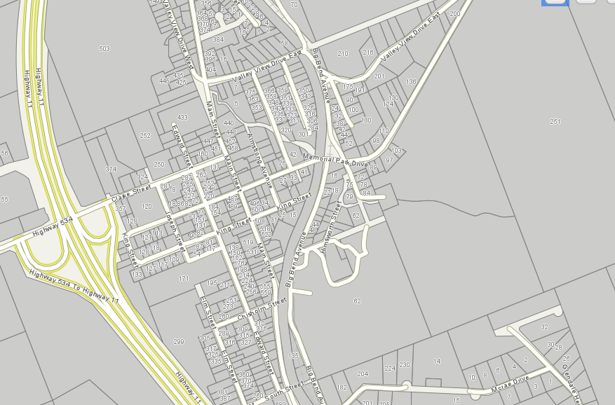
SUBJECT LANDS

PROPOSED ZONING BY-LAW AMENDMENT

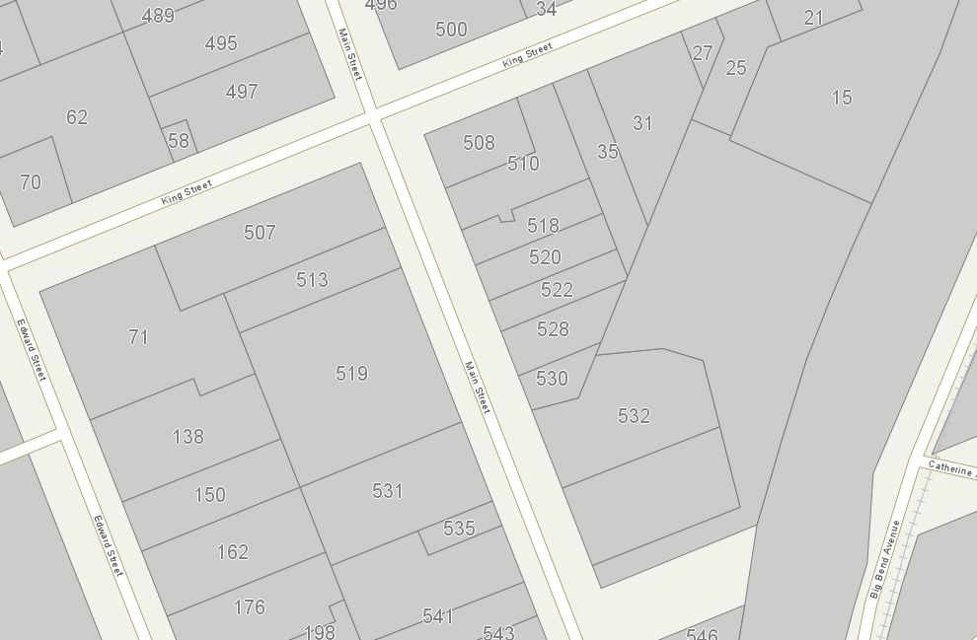
Lands to be rezoned from
CV1 (Village Commercial) to
CV1-6 (Village Commercial - Exception Six)

